1. **Agenda**:
   1. In this and next lectures, we will create a Maven Project to create a JMS Client.
2. 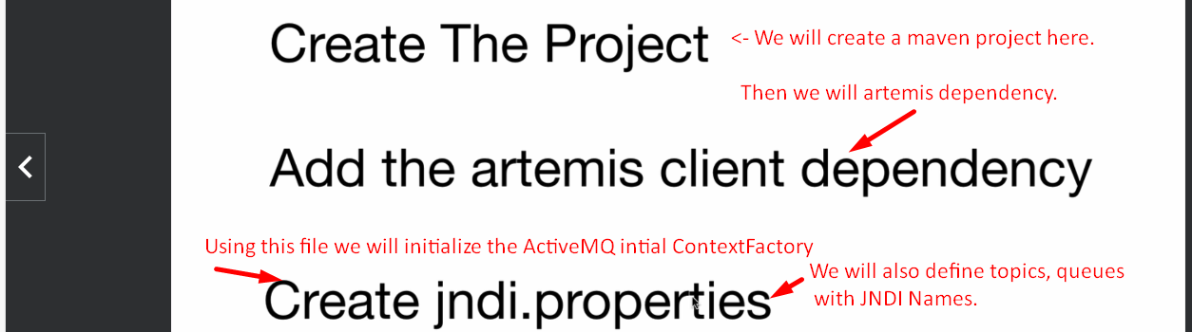
3. 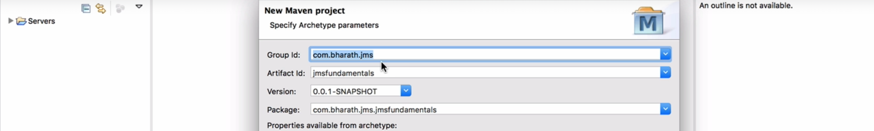
4. 